See Screening Sheet on page D-46 of Pub 4012 to determine if COD is in scope.

Taxpayer receives a 1099-C from a credit card company or bank. The amount of the debt canceled is shown in Box 2 of 1099C.
- Canceled debt is generally considered income and is reported on the 1040, line 21, other income, UNLESS the taxpayer was in bankruptcy or insolvent (i.e., the taxpayer’s liabilities exceeded assets) immediately before the debt was canceled.
- If the taxpayer was in bankruptcy or insolvent immediately before the debt was canceled, all or part of the canceled debt may be excludable from income.
  - Cases involving bankruptcy or insolvency are OUT OF SCOPE...
- The preparer needs to ask taxpayer if they were in bankruptcy or might have been insolvent immediately before the debt was canceled; if “yes” or “not sure,” we must refer the client to a paid preparer. (OUT OF SCOPE)
- The debt must be personal (i.e. NOT related to a business)
  - Cases involving business related debt are OUT OF SCOPE...
- Credit card cancellation of debt is reported on a 1099-C if the amount is over $600. Any amounts less than $600 not reported on a 1099-C are still taxable.
- The amount of interest shown in box 3 can be ignored since it is included in box 2 and is taxable.
- All other types of forgiven debt including Qualified Principal Residence Indebtedness is OUT OF SCOPE.
- Cancellation of debt amounts are not taxable in NJ and must be removed from the NJ return.

Example
Fred runs up $15,000 in credit card debt and can’t pay. He works out a deal with the credit card company to settle for $10,000 and the rest of the debt is canceled. Fred was solvent immediately before the debt was canceled. Fred receives a 1099-C from the creditor shown below: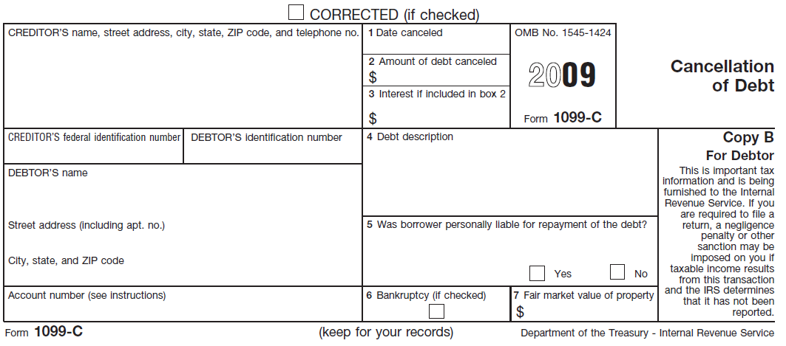
16
Big Bank
1 Big Plaza
Gotham, DE 11001
05/05/2016
5,000.00
X
Fred Doe
123 Elm St

Anytown, YS 12345
The consequence is $5,000 of taxable income which is reported on the 1040, line 21, other income, as CANCELLED DEBT.

Step 1: In TSO, enter 1099-C in the search box..

Step 2: Enter the creditor’s name, creditor’s federal identification number, and the amount of debt credited.

Step 3: Select

Step 4: Enter the amount of debt credited on the NJ Checklist – Adjustments to Line 25 – Other Income

Step 5: After completing the federal return, enter the amount from the NJ Checklist as a negative number into the NJ return.
Income Subject to Tax – Taxable Amount of Scholarships included on Federal Return

